BREAKFAST CHATTER
Weekly Bulletin of Rotary Club of Kathmandu Mid-Town
District 3290 Volume No. 15/26 for #768 January 21, 2005
www.rotarymidtown.org.np
JANUARY IS STILL ROTARY AWARENESS MONTH
SUNSHINE ANNOUNCEMENT FOR THE WEEK OF 21 JANUARY, 2005;
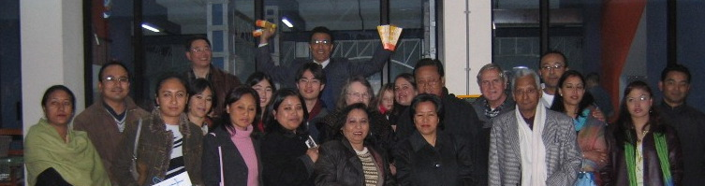
Sunshine greetings on the 21st to Lalana, spouse of Kailash!
Film Review Board of Kathmandu Mid-Town goes to the movies
*********** MEETING ACTIVITIES:
DATE | ACTIVITY | SUBJECT
21 JAN | ADRA | Youth Reproductive Health Education Project (ABC)
28 JAN | CLUB ASSEMBLY | Financials etc
04 FEB | KRISHNA BHATTARAI | Achievements at HRDC
11 FEB | DEEPAK SHERCHAN | TBA
18 FEB | SUMAN THAPA | TILGANGA AND GLAUCOMA ?
19? FEB | PICNIC | PLACE?? SUGGESTIONS WELCOMED

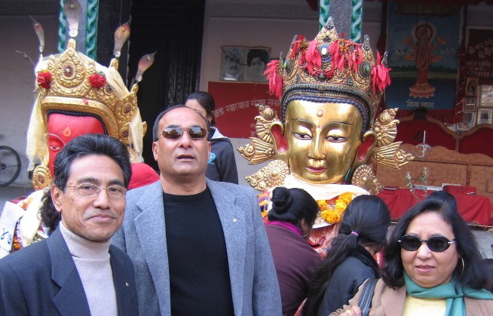
****************
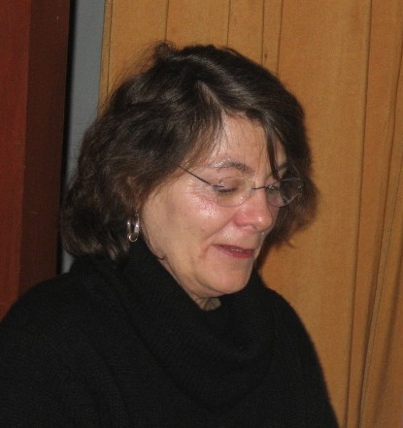
NEWS: We may have a picnic on/about Feb 19. Venue, fooding & transport ideas, please contact David … The once-in-12-year display of Dipankar statues in K’du Durbar was very impressive … Thanks to Cheryl Colopy for sharing her thoughts on radio journalism and good wishes for her third adventure in Nepal…
**************** This Friday our speakers will be Chandeswori Tamrakar and Chantelle Allen from ADRA. RC Mid-Town has collaborated with ADRA in health care training. This will be an excellent opportunity to find out what has been done where, and to consider what we can do in the future.

. YIR…David

